5.0. Multiple Device Synchronization
Because different devices start recording at different times, their data streams need to be synchronized to allow accurate multi-device analysis. This section explains how to set up and use Lab Streaming Layer (LSL) to align and record data from multiple devices.
5.1. Activate LSL streaming
For data synchronization coming from multiple devices we are using Lab Streaming Layer (LSL). LSL is collecting all the streams detected and associate a label for each for distinction. To activate LSL streaming, the process differs depending on the device.
Polar devices :
You’ll need to compile main.py for streaming all Polar devices. This script detects all polar devices in the room and lets you choose which to stream, one by one. It relies on PolarOH1_LSL.py (LSL streaming for Polar OH1) and PolarH10_LSL.py (LSL streaming for Polar H10).
Emotibit devices :
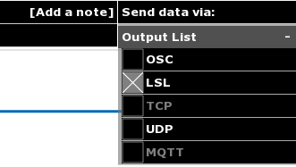
[Image 1 : Emotibit Oscilloscope interface]
The Emotibit Oscilloscope software already contains the option to stream with LSL on the top right of the interface [image 1].

For more information about LabStreamingLayer, consult on https://labstreaminglayer.readthedocs.io/ website.

5.2. Record the streaming data
To select your streams of interest and be able to record them, download LabRecorder.
Select a browser to choose the location of the upcoming saved file and enter a distinct name below. The name should look like : « thename.xdf ». Your file will be saved as an XDF file which is not readable with basic tools.

5.3. Display and extract data
After recording and saving the ongoing streams in a file, you can visualize those on a graph depending on the time by using readxdf.py.
For further analysis, you can extract each stream in a different CSV file by using the fromXDFtoCSV.py script.

